11. Write a program in C to calculate the square of the number using inline functions and macros both.

#include<iostream>

using namespace std;

class square

{private:

int n,r;

float n1,r1;

public:

void input();

void calc();

void display();};

inline void square::input()

{cout<<"Enter an integer :: ";

cin>>n;

cout<<"\nEnter a float no. :: ";

cin>>n1;}

inline void square::calc()

{r=n*n;

r1=n1*n1;}

inline void square::display()

{cout<<"\nSquare of integer [ "<<n<<" ] = "<<r<<"\n";

cout<<"\nSquare of float [ "<<n1<<" ] = "<<r1<<"\n";}

int main ()

{ square s;

s.input();

s.calc();

s.display();

return 0;}

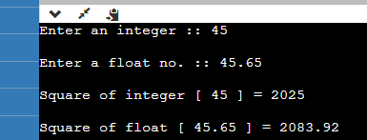

10. Write a program to implement sorting an array.

#include <iostream>

#include <algorithm>

using namespace std;

const int ARRAY_SIZE = 10;

int main() {

int arr[ARRAY_SIZE] = {3, 7, 1, 5, 2, 8, 4, 6, 9, 0};

cout << "Original array: ";

for (int i = 0; i < ARRAY_SIZE; i++) {

cout << arr[i] << " "; }

cout << endl;

sort(arr, arr + ARRAY_SIZE, greater<int>());

cout << "Sorted array: ";

for (int i = 0; i < ARRAY_SIZE; i++) {

cout << arr[i] << " "; }

cout << endl;

return 0;}

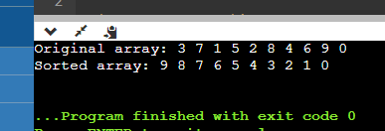

5. Write a program which takes 2 arrays of 10 integers each, a and b. c is an array with 20 integers. The program should put into c the appending of b to a, the first 10 integers of c from array a, the latter 10 from b. Then the program should display c.

int main()

{int a[10],b[20],c[20];

int sizeofa = sizeof(a)/sizeof(a[10]);

int sizeofb = sizeof(b)/sizeof(b[10]);

int sizeofc = sizeof(c)/sizeof(c[10]);

cout<<"Enter elements of array a:"<<endl;

for(int i=0;i<sizeofa;++i)

{ cout<<"Enter element"<<i+1<< ": ";

cin>>a[i];

c[i] = a[i];}

cout<<"Enter elements for array b:"<<endl;

for(int i=0;i<sizeofb;++i)

{cout<<"Enter elements"<<i+1<<": ";

cin>>b[i];}

for(int i=0,k=sizeofa;k<sizeofc && i<sizeofb;i++,k++)

{c[k] = b[i];}

cout<<"c :";

int minimum = c[0];

for(int i=0;i<sizeofc;i++)

{cout<<c[i]<<" ";

if(minimum > c[i])

minimum = c[i];}

cout<<"Minimmum if array c:"<<minimum<<endl;

return 0;}

9. Write a program to multiply 2 matrices.

#include<iostream>

using namespace std;

#include<conio.h>

int main()

{

int mat1[2][2], mat2[2][2], mat3[2][2], sum=0, i, j, k;

cout<<"Enter First Matrix Element (2*2): ";

for(i=0; i<2; i++)

{for(j=0; j<2; j++)

{cin>>mat1[i][j];} }

cout<<"Enter Second Matrix Element (2*2): ";

for(i=0; i<2; i++)

{for(j=0; j<2; j++)

{cin>>mat2[i][j];} }

cout<<"Multiplying two Matrices........\n";

for(i=0; i<2; i++)

{for(j=0; j<2; j++)

{sum=0;

for(k=0; k<2; k++)

{sum = sum + mat1[i][k] * mat2[k][j];}

mat3[i][j] = sum;}}

cout<<"\nMultiplication of Two Matrices : \n";

for(i=0; i<2; i++)

{for(j=0; j<2; j++)

{cout<<mat3[i][j]<<" ";}

cout<<"\n";}

return 0;}

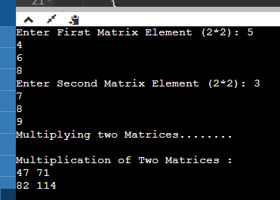

8. Write a program to add 2 matrices.

#include<iostream>

using namespace std;

int main()

{ int mat1[3][3], mat2[3][3], i, j, mat3[3][3];

cout<<"Enter Elements of First Matrix: ";

for(i=0; i<3; i++)

{for(j=0; j<3; j++)

cin>>mat1[i][j];}

cout<<"Enter Elements of Second Matrix: ";

for(i=0; i<3; i++)

{for(j=0; j<3; j++)

cin>>mat2[i][j];}

cout<<"\nAdding the Two Given Matrix...\n";

for(i=0; i<3; i++)

{for(j=0; j<3; j++)

mat3[i][j] = mat1[i][j]+mat2[i][j];}

cout<<"Addition Result of Two Given Matrix is:\n";

for(i=0; i<3; i++)

{for(j=0; j<3; j++)

cout<<mat3[i][j]<<" ";

cout<<endl;}

return 0;}

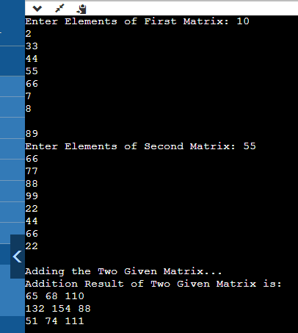

7. Write a program to handle the command line arguments entered by the user.

#include <iostream>

using namespace std;

int main(int argc, char** argv)

{

cout << "You have entered " << argc << " arguments:"

<< "\n";

for (int i = 0; i < argc; ++i)

cout << argv[i] << "\n";

return 0;

}

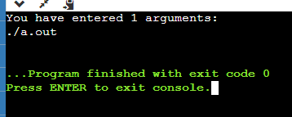

4. Write a program that asks the user to take array of 10 integers. The program will then display either "the array is growing", "the array is decreasing", "the array is constant", or "the array is growing and decreasing."

#include <iostream>

using namespace std;

const int N=10; int main()

{ int a[N],i; bool found=false; bool up=false,down=false;

cout << "Please enter an integer: "; cin >> a[0];

for(i=1;i<N;i++) { cout << "Please enter an integer: ";

cin >> a[i]; if(a[i-1]>a[i]) down=true; if(a[i-1]<a[i]) up=true; }

cout << "the table is " << (up? (down? "increasing and decreasing": "increasing"): (down? "decreasing": "constant")) << endl; return 0; }

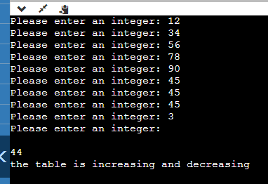

3. Write a program that asks the user to take array of 10 integers. The program will then sort the array in descending order and display it.

#include <iostream>

using namespace std;

int main()

{int arr[15];

int n, i, j;

int temp;

cout << "Enter total number of elements to read: ";

cin >> n;

if (n < 0 || n > 15) {

cout << "Input valid range!!!" << endl;

return -1;}

for (i = 0; i < n; i++) {

cout << "Enter element [" << i + 1 << "] ";

cin >> arr[i];}

cout << "Unsorted Array elements:" << endl;

for (i = 0; i < n; i++)

cout << arr[i] << "\t";

cout << endl;

for (i = 0; i < n; i++) {

for (j = i + 1; j < n; j++) {

if (arr[i] < arr[j]) {

temp = arr[i];

arr[i] = arr[j];

arr[j] = temp; }}}

cout << "Sorted (Descending Order) Array elements:" << endl;

for (i = 0; i < n; i++)

cout << arr[i] << "\t";

cout << endl;

return 0;}

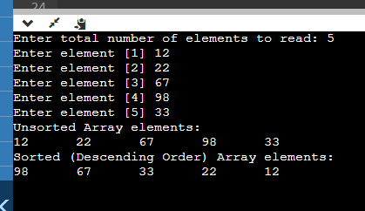

2. Write a program that asks the user to take array of 10 integers. The program must output the largest element in the array, and the index at which that element was found.

#include <iostream>

using namespace std;

int main()

{

int i,l,a[10],j,w;

cout<<"Enter 10 numbers \n";

for( i=0;i<10;i++)

{

cin>>a[i];

}

l=a[0];

for( j=0;j<10;j++)

{

if(a[j]>l)

{

l=a[j];

w=j;

}

}

cout<<"Largest is "<<l<<"at the index"<<w<<endl;

return 0;

}

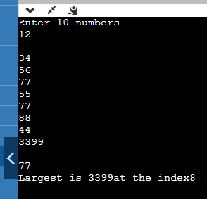

1. Write a program that asks the user to take array of 10 integers. The program must compute and write how many integers are greater than or equal to 10.

#include<iostream>

using namespace std;

int main()

{

int count =0;

int numbers[10];

cout<<"Enter 10 integers"<<endl;

for(int i=0;i<10;i++)

{

cin>>numbers[i];

}

for(int j=0;j<=10;j++)

{

if(numbers[j]>=10){

//cout<<numbers[j]<<endl;

count++;}}

cout<<"Number greater than 10 is:"<<count<<endl;

return 0;}

